**REPORT**

# KITCHEN STORY

By,

ANANT KHAIRNAR

([anantkhairnar121@gmail.com](mailto:anantkhairnar121@gmail.com))

GitHub links ; https://github.com/anantkhairnar/kitchen-story.git

## OVERVIEW

The project ‘THE TASTY KITCHEN’ is a restaurant website made using HTML and CSS for customers to get to know about the restaurant.

## GOALS

* Landing page for the restaurant.
* To provide the information about the restaurant.
* To provide the recipe menu list and services provided by the restaurant.
* Directing the website visitors to order the food in a food ordering website like zomato.
* Making the website visitors to follow the social media page of the restaurant.

## SPECIFICATIONS

* We added a logo and navigation bar items for easy use of the website.
* Added the picture with details of the recipes and the information services provided by the restaurant.
* People can use Contact Us form to give feedback or for any queries.

## TOOLS

* HTML
* CSS
* VS code
* Google Fonts

## FILE ​ STRUCTURE​

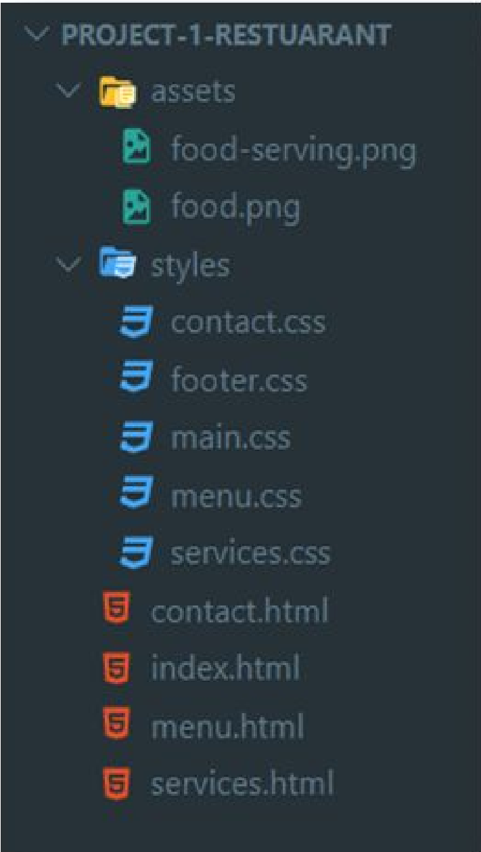

## SOURCE ​ ​CODE

[Full source code Github repository link:](https://github.com/darshanr27/restaurant-project) https://github.com/anantkhairnar/kitchen-story.git

### HTML

* index.html [https://github.com/anantkhairnar/Kitchen-Story/blob/main/ index.html](https://github.com/anantkhairnar/Kitchen-Story/blob/main/%20index.html)
* menu.html [https://github.com/anantkhairnar/Kitchen-Story/blob/main/ menu.html](https://github.com/anantkhairnar/Kitchen-Story/blob/main/%20menu.html)
* services.html [https://github.com/anantkhairnar/Kitchen-Story/blob/main/ services.html](https://github.com/anantkhairnar/Kitchen-Story/blob/main/%20services.html)
* contact.html [https://github.com/anantkhairnar/Kitchen-Story/blob/main/ contact.html](https://github.com/anantkhairnar/Kitchen-Story/blob/main/%20contact.html)

### CSS

● styles [https://github.com/anantkhairnar/Kitchen-Story/tree/main/ styles](https://github.com/anantkhairnar/Kitchen-Story/tree/main/%20styles)

## OUTPUT

Note: Recommended the desktop view is best, not responsive to mobile screen.

### HOME

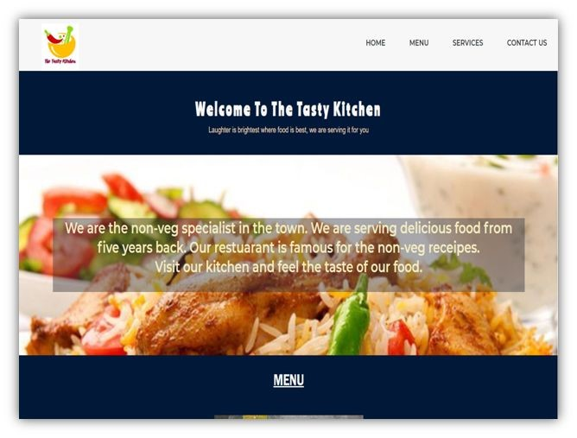

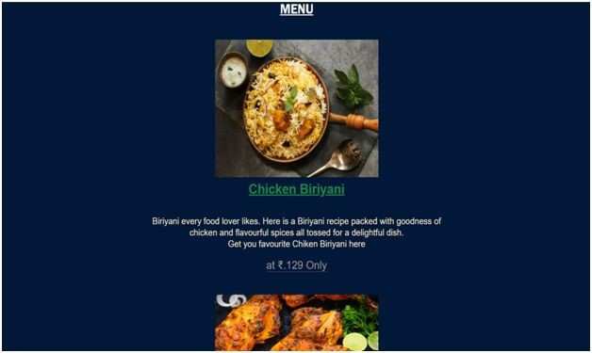

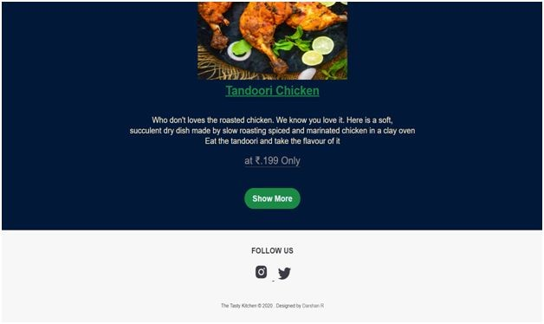

### MENU

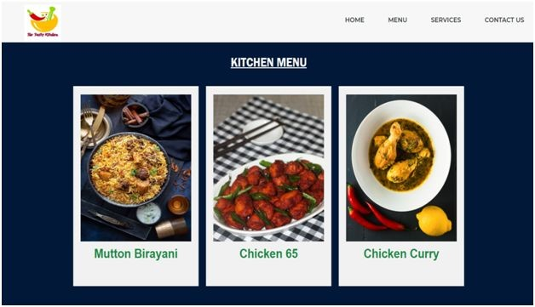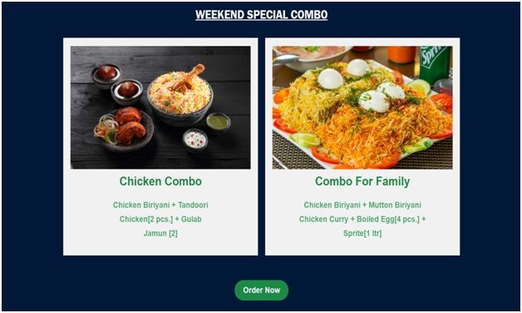

### SERVICES

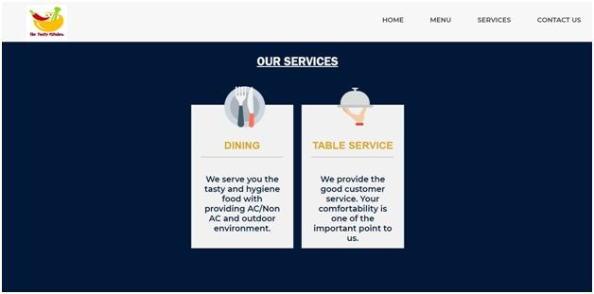

CONTACT US

# THE END THANK YOU